Capstone Project Prospectus and Registration information
Spring 2021
Students:
ID | Last name ('family') |  | First name ('private') | e-mail
205717077 | Golan |  | Saar | Saar.Golan@e.braude.ac.il
316216571 | Nadler |  | Roni | Roni.Nadler@e.braude.ac.il
Category: |  | research | Date of submission for registration:

Supervisor' approval:
Name: Miri Weiss Cohen
E-mail: miri@braude.ac.il

Gait evaluation using Skeleton Motion Detection from Videos using CNN

Prospectus
Synopsys:
Nowadays, healthcare centers are not familiar with quantitative approaches for patients’ gait evaluation. Hence the need for detailed human gait detection system. Human gait refers to the various locomotion of a human using their limbs. A gait evaluation depends on various parameters.
Our research project aimed to provide a method to obtain the skeleton features ands characterizing patients’ gait performance. This will be done in a bi-level procedure: First, detecting the person in hand from a video taken in the rehabilitation center. Second, to skeletize this output via CNN. . The project is based on using and developing a YOLO algorithm for our project, and developing and testing CNN various architecture to solve this problem. YOLO is a real-time object detection method, introduced for motion detection in complex scenes. CNN are deep learning methods for classification through a learning process.

Scope of the project:

The project is designed to provide identification and classification of patient's proper gate using Deep Learning. In order to assess patient's gait we use the parameters described in the following table.
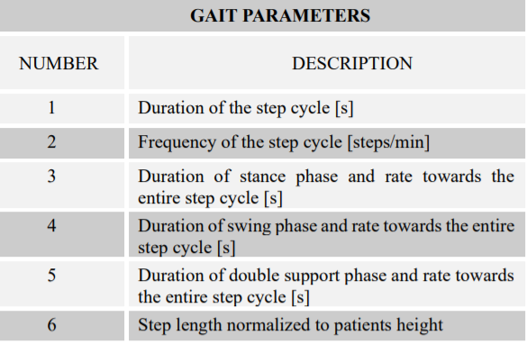

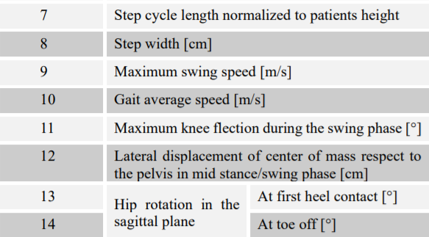
As part of the project, we will develop an application that is able to take as input RGB video and automatically generate skeleton figures characterizing patients’ gait performance.

The project focuses on several technologies:
Machine learning and Medical Imaging data analysis. Our challenge is to develop and implement machine learning by using deep networks for image processing. .

YOLOv4 – exhibits one of the best CNN representatives You Only Look Once (YOLO), which breaks through the CNN family's tradition and innovates a complete new way of solving the object detection with most simple and high efficient way. ).
Research and test various different CNN architectures and optimization hyper parameters. There is a plethora of CNN architectures. Therefore, we will research and test different CNN architectures to get the best solutions.

Unique feature

This is a unique project that use CNN to analyze patient's gait and the quality of it by making it measurable. Thus, using a simple RGB camera only allows healthcare centers to assemble an accurate and faster rehabilitation plan for patients. This novel (if successful) will offer an online video quantification gait system.
This will allow a sufficient and reliable system for gait evaluation using Skeleton Motion Detection from Videos

